IUCEE-EWB HITAM

ABOUT IUCEE-EWB HITAM :
IUCEE-EWB HITAM has been established as a non-profitable chapter on 17th AUG 2019. We think the practical implementation is required for every engineer to solve community-oriented problems. EWB-INDIA is a professional organization in which both physically and mentally activity or duties are performed to serve the community with different skills, in the development of positive change. We have been inspired by the goals of EWB-INDIA and it is our concern to increase sustainable rural development, assisting in capacity building in backward rural and urban communities of India, protecting the country’s natural resource base and working across national boundaries for social and economic justice and responsible use of technology.
VISION:
To become global leaders by taking up society based engineering projects and work for sustainable solutions.
MISSION:
• To be inclined to social service using engineering skills
• To come up with innovative ideas for reducing the pain of society
• To be sensitive and conscious about the societal structure
• To work with society and experience dealing with ethical dilemmas

Working principle:
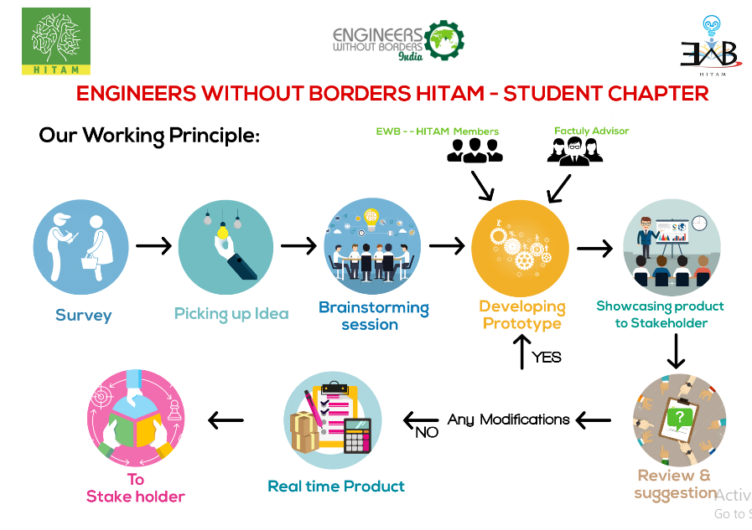

Faculty Coordinator:
- Mr Santosh Naik
Faculty Advisor:
- Mr Surendra Bandi
- Mrs Hema Mahajan
Office Bearers:
- President - Syed Majeedullah
- Vice-President - Aashish Sharma
- Secretary - B Sai Chandrika
- Treasurer - Praveen Kullu
- Public Relation - Alankar Achadian

Project Managers:
- N Ravali
- Vishwanadha Varma

Department Coordinator:
- EEE Dept - S.BHARGHAV
- CSE Dept - RAHUL AGARWAL
- MECH Dept - Y.NAGARJUNA REDDY
- ECE Dept - P.V.S PRANAY

EWB-HITAM LOGO:

Motivation to start EWB Chapter:
Engineers are meant to make lives easier for common people or so was it in the past. Just by being born in a particular family or region can dictate your access to basic human needs these can range from food, shelter to education. And it's the responsibility of those who are born in the families and regions with everything available to assist those who struggle with these things. We want to encourage the present engineers in volunteering into community service not just to assist those in need but also to improve oneself.

Activities to be undertaken:
- Feasible recreational projects.
- Awareness about community service.
- Projects to promote education in backward communities.
- Awareness to promote sanitation and conservation of natural resources.

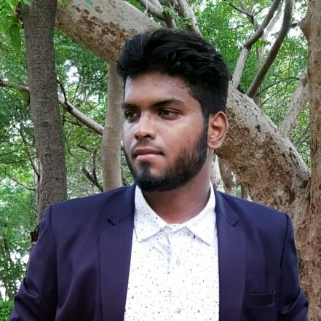
Core Committee:
Syed Majeedullah, President.
ECE, 3rd Year
As President of EWB-HITAM student Chapter. My primary duty is to preserve and maintain a positive environment with a collaborative effort between all the EWB-HITAM members. I ensure that everybody is contributing to the mission and vision of the EWB-HITAM Chapter. I will make sure that in my legacy all the EWB members inducing me to serve the community and fight for the community.
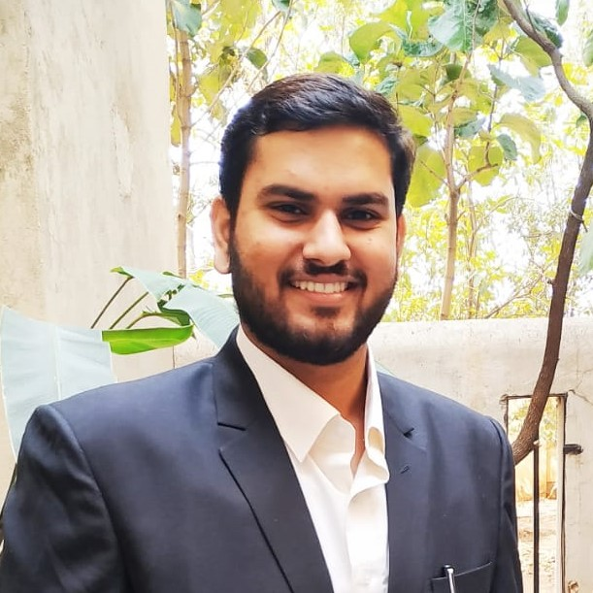
Aashish Sharma, Vice President.
MECH, 2rd Year
As the Vice President of EWB-HITAM, I have to ensure that all the members do their jobs in a given time and follow the right protocol. Also, it is my responsibility to address any inconveniences that the members might face.

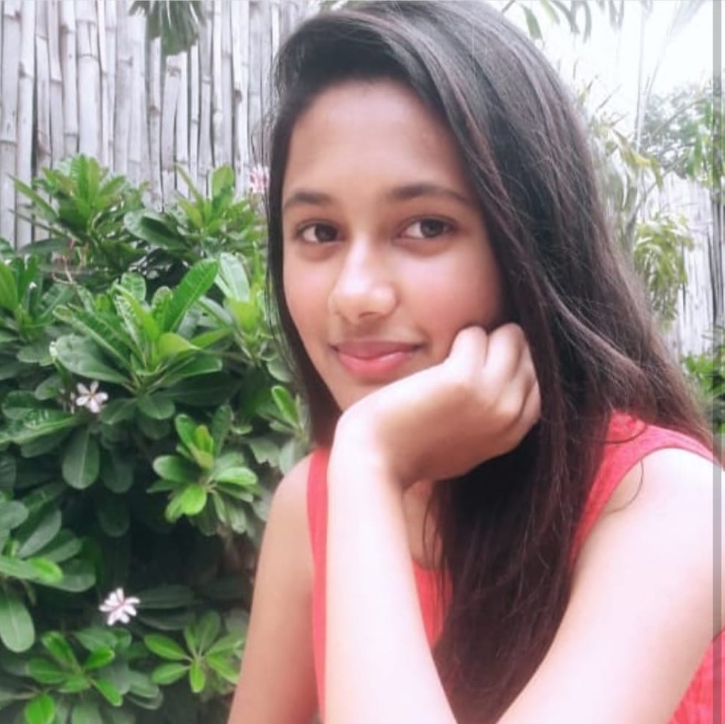
B Sai Chandrika, Secretary.
ECE, 3rd Year
As a secretary of the EWB-HITAM chapter, I have to keep track of work done and maintain records. I ensure that our chapter will deliver good projects and I will make sure that it will be done properly.
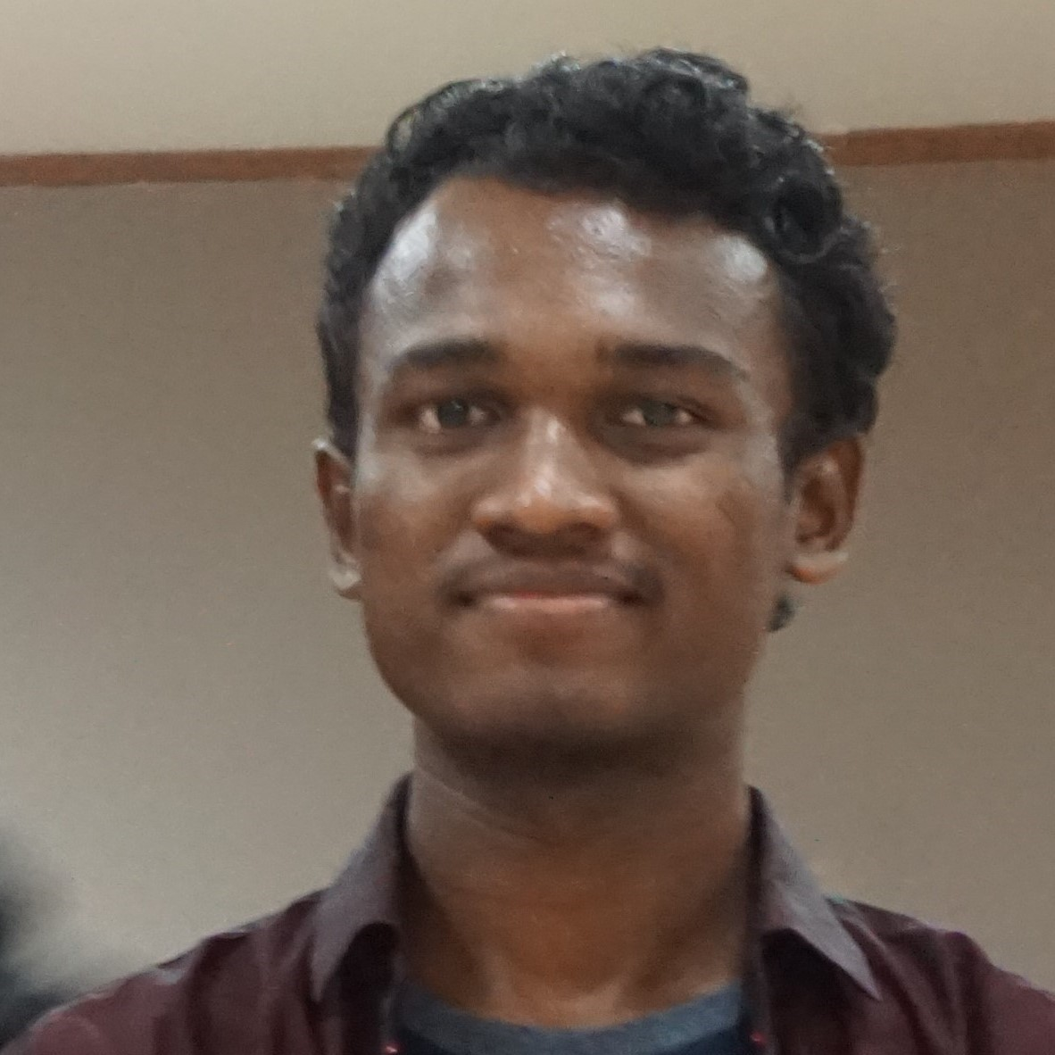

Praveen Kullu, Treasurer.
ECE, 3rd Year
As the Treasurer, I am the custodian of the funds relating to the EWB-HITAM Student Chapter. It's my responsibility that I maintain Transparent accounts and ensure that accounting procedures are followed in the Student Chapter.

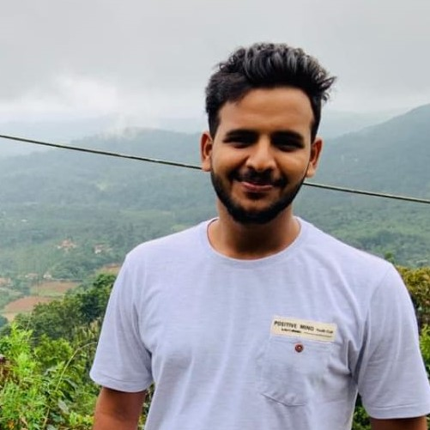
Alankar Achadian, PR & Social Media HEAD.
MECH, 3rd Year
Being a PR (Public Relations) Head, I have to coordinate and participate in the preparation of internal promotional publications and includes, organizing, supervising, for every event. The newsletter updates on social media regularly as well as for promotions go through me.
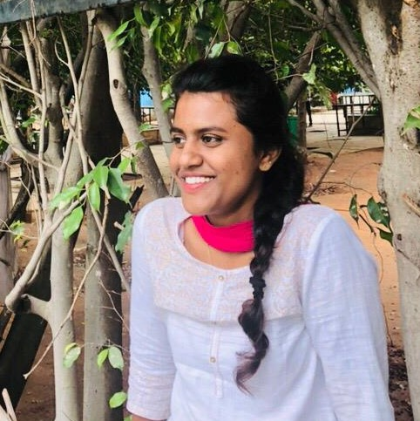

N Ravali, Project Manager.
ECE, 3rd Year
As the project manager, I take the responsibility of initiating and motivating the team working for a project in EWB-HITAM. It would be me who will ensure the completion of these projects and their delivery.
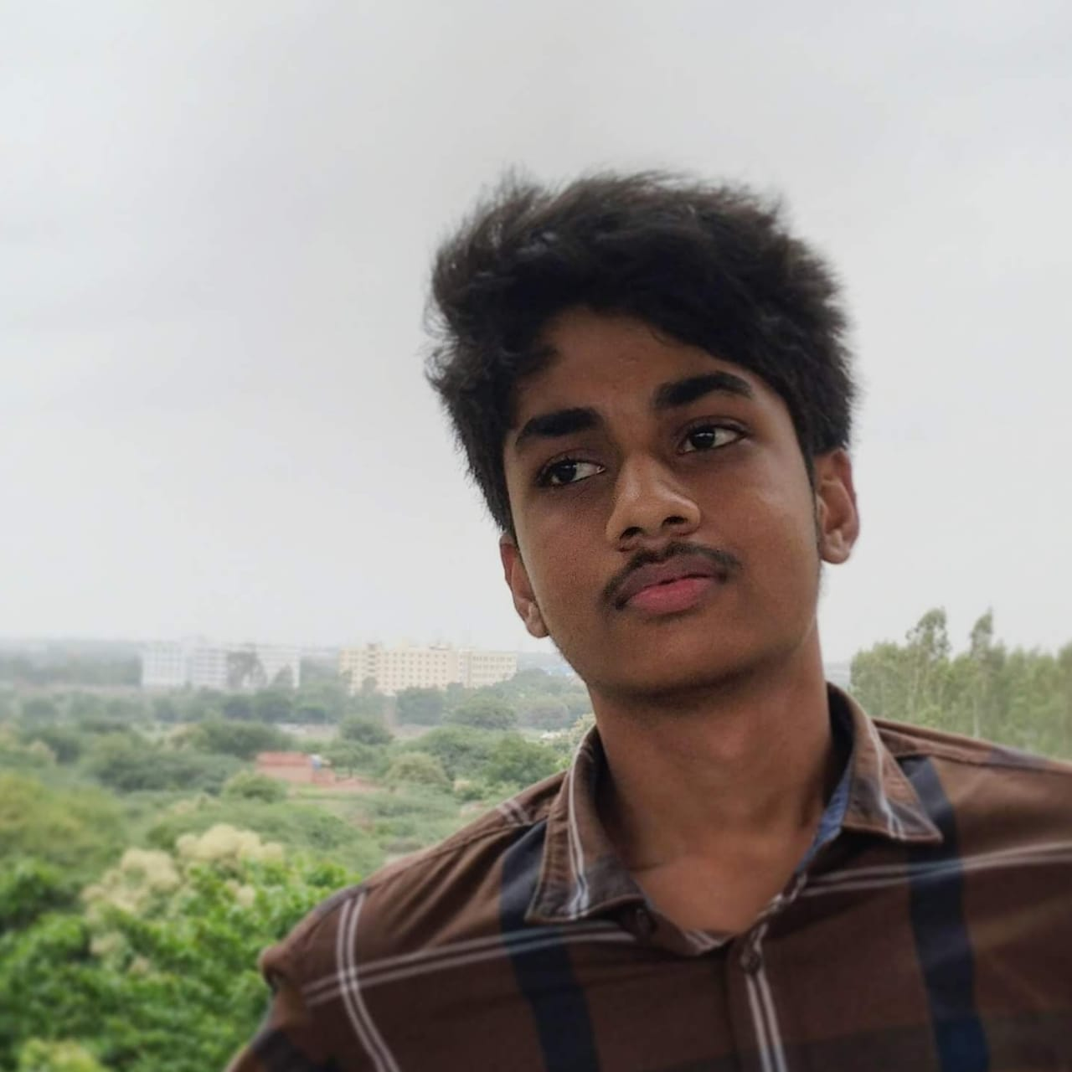

Purna Viswanadha Varma, Project Manager.
MECH, 2rd Year
I will undertake the responsibility of completion of projects and work alongside the Secretary for detailed documentation of projects and their progress will be communicated to the president regularly.

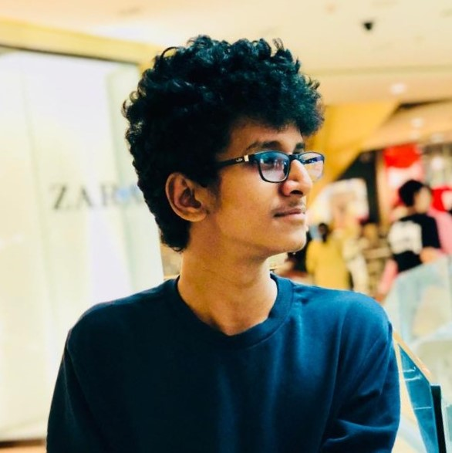

P V S Pranay, ECE Coordinator.
ECE, 3rd Year
I'm responsible for the work of the assigned people which are under my observation that is of electronics and communication department, As a coordinator in EWB-HITAM. I’ll make sure that every student should get a sense of the real engineering to make the project successful.

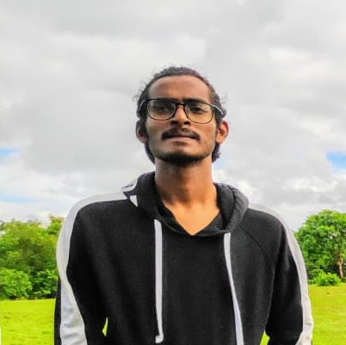
Y Nagarjuna Reddy, MECH Coordinator.
MECH, 2rd Year
I will be responsible for the mechanical department of the EWB-HITAM Chapter and encourage new students to join the chapter and do their best for the chapter and see that they are actively participating in work sessions and meetings.
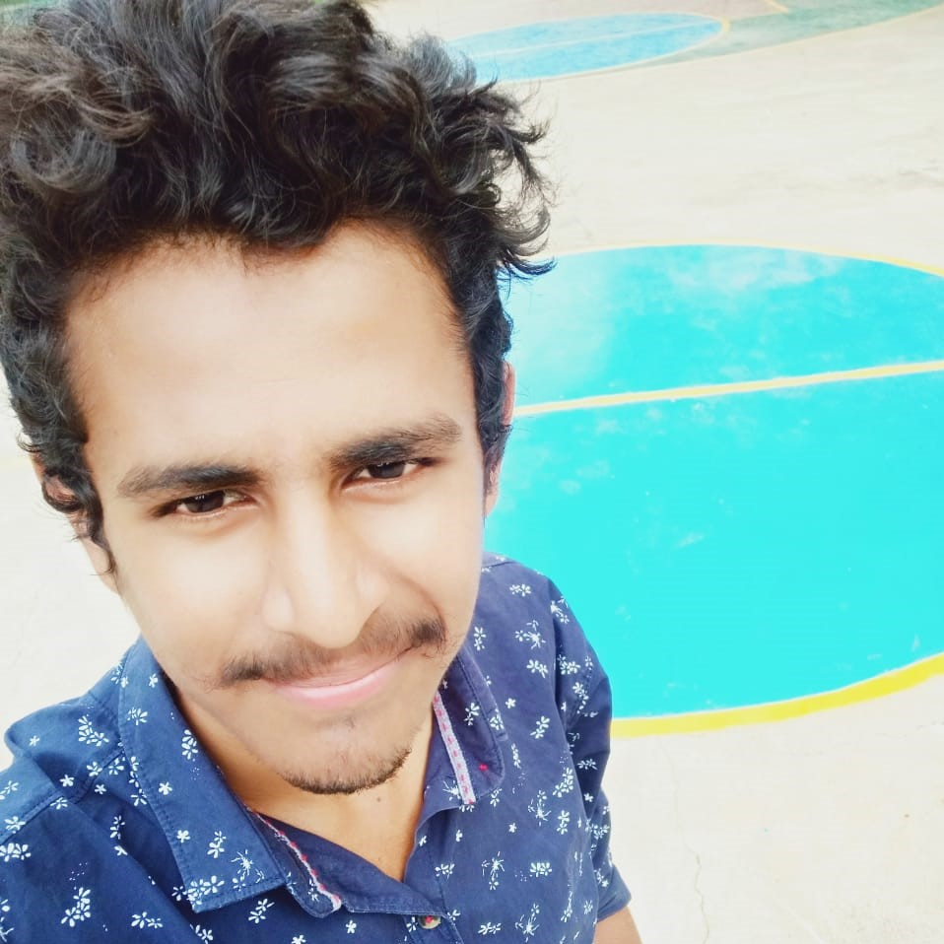

S Bhargav, EEE Coordinator.
EEE, 3rd Year

As the student EEE department coordinator in EWB-HITAM. I will support the students from the electrical department to bring up their valuable ideas to the community for making possible solutions and we encourage the EEE department projects and innovations in EWB-HITAM for the better nation.
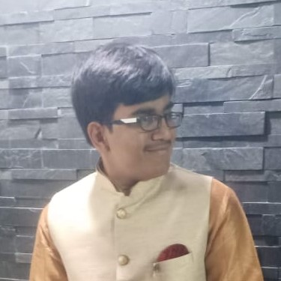

Rahul Agarwal, CSE Coordinator.
ECE, 3rd Year
I am the CSE coordinator which means I will be tasked with involving the CSE department into EWB-HITAM and make sure that they have active participation.

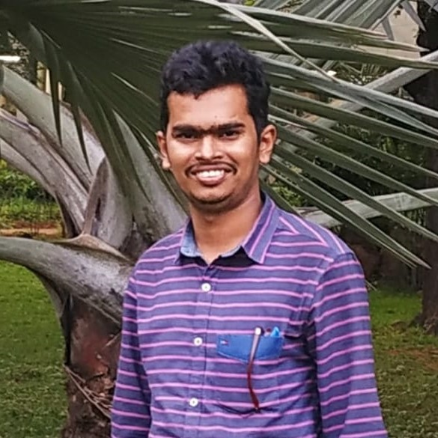
Santosh Naik, Faculty Coordinator.
Mr. Santosh Naik is presently working as an Assistant Professor in the Department of Mechanical Engineering, at HITAM, Medchal, India. He is having 3+ years of teaching experience. His areas of interest are Fracture Mechanics, Composite Materials. He published papers in 8 International Journals. Participated in 3 International and 7 National conferences.

